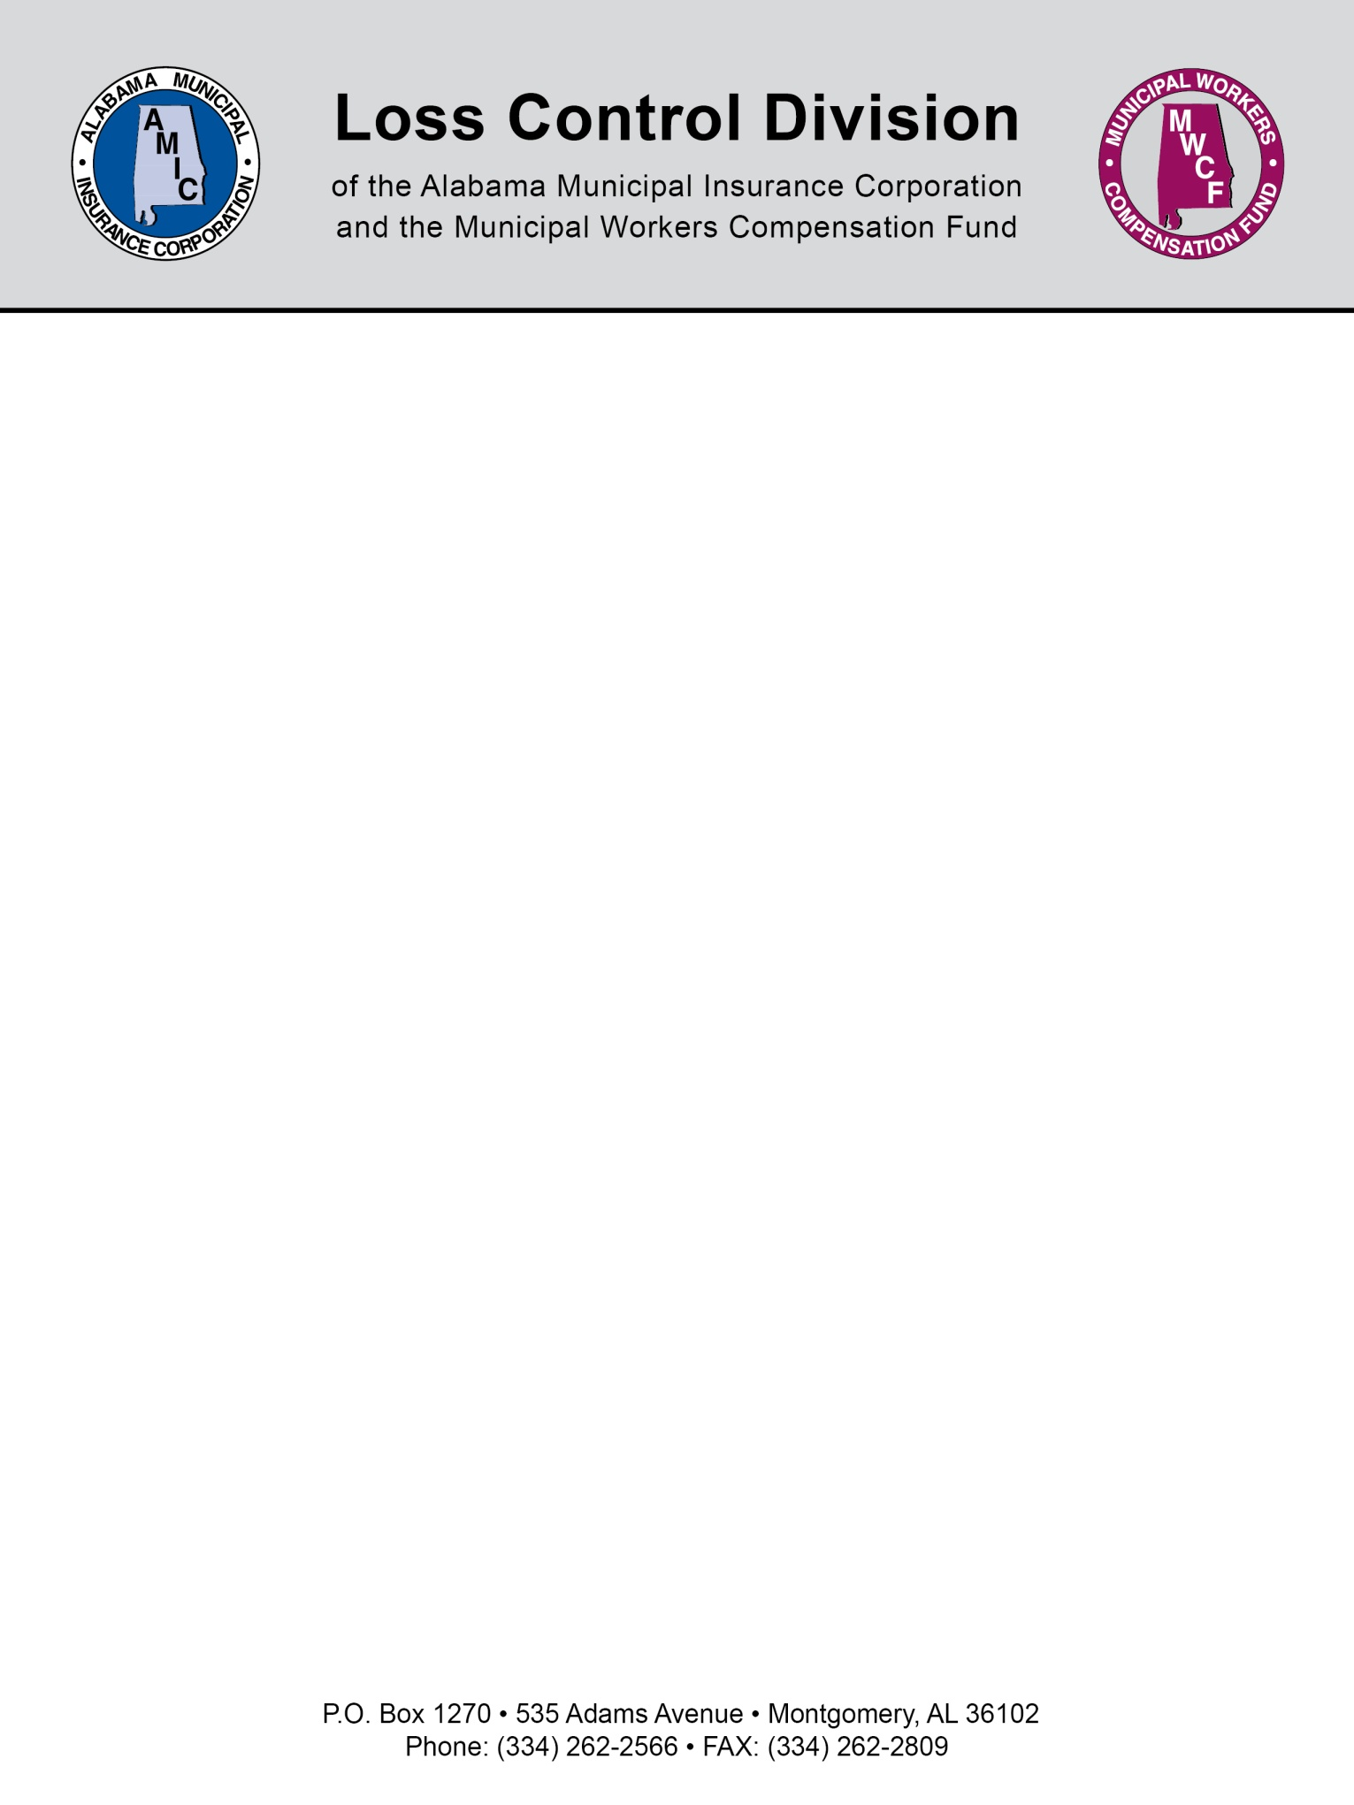

Safety Meeting Guidelines
1. Select appropriate topic. It’s best to concentrate on one problem area than to use the shotgun approach and briefly mention numerous topics.
2. Review past accident injury experience. Let employees know why this topic is being covered.
3. Ask how each accident could have been prevented. Try to get employees to participate in the meeting.
4. Inform employees of proper procedures to be followed. Be through and encourage questions. (The employee safety coordinator will provide information when possible.)
5. Provide an actual demonstration. Let a foreman or qualified employee go through the procedure.
6. Show a supporting video, slide show, etc., if available. Videos are a great teaching aid when used properly. Employees retain information much easier when the message is combined with a visual image.
7. Close with comments on the importance of following procedures. You should also stress benefits to employee, employee’s family, and the municipality.
8. Ask for any questions or comments from employees.
9. Post proper procedure poster, etc., on a bulletin board for employees to review at their convenience.
10. Document those in attendance and the topics discussed.
Rev 8/2013
NOTE: This document is not intended to be legal advice. It does not identify all the issues surrounding the particular topic. Public agencies are encouraged to review their procedures with an expert or an attorney who is knowledgeable about the topic. Reliance on this information is at the sole risk of the user.

